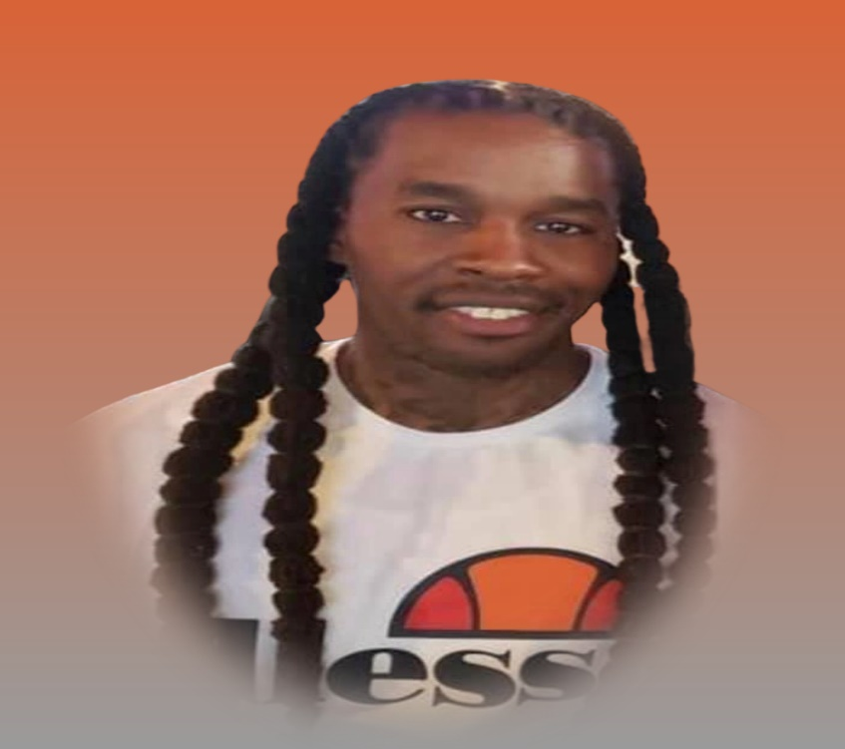
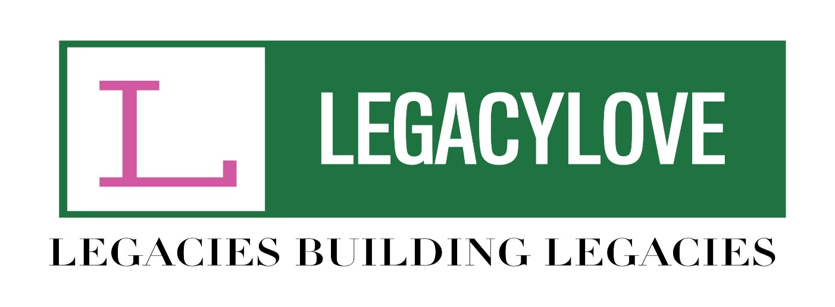
DIOSA D. CLYBURN II
ATHLETIC SCHOLARSHIP

SCHOLARSHIP INFORMATION PACKET
Deadline: JUNE 1, 2022
(For Baltimore County & Baltimore City High School Seniors)
Dear Scholarship Candidate:
The mission of LegacyLove Inc is to inspire, support, mentor and provide resources for students as they become productive and independent citizens in our society. We strive to support the goals of young people by offering a scholarship to deserving students. This scholarship is in honor of Diosa D. Clyburn II, who passed away at the young age of 36 after a brief illness. He had a very competitive spirit and an unwavering love for sports…especially Football and Basketball. He shared his passion with many young people by coaching and encouraging on and off the field. This scholarship is being offered to a student who has participated on a high school sports team for at least 2 of the four years. Applicants for this $1000 scholarship must also meet the eligibility criteria of having a minimum GPA of 2.5 along with an acceptance into 4-year college/university. You must also complete the Application Form and submit all required documentation by JUNE 1, 2022. Your completed application packet must include:
- A typed Application Form
- A Recent Photograph (Head Shot Preferred)
- An official copy of your high school transcript
- Two letters of recommendation (one from a teacher/guidance counselor and one from a coach for the sports team you participated in). Each letter must be typed on official letterhead. A daytime contact number and signature of the person writing the recommendation are required for both letters. NO HANDWRITTEN LETTERS WILL BE ACCEPTED
- Essay (500 Words) – Your essay must include your future aspirations and what you have done and/or plan to do to reach your goals. Also, please include your thoughts about your experience on the sports team. Your essay must be typed and can be submitted as added pages or an attachment to this packet.
- Letter of Acceptance

All completed, neatly typed packets must be returned to the Scholarship Committee by Wednesday, June 1, 2022. There will be NO EXCEPTIONS TO THE DEADLINE. The Scholarship Committee members will review the applications and notify you if you are selected by June 30, 2022. Your application can be submitted by email to support@legacylove.net or faxed to 443.526.6924. Scholarship funds will be sent to the school you will be attending. If you have any questions, please call 443.913.3910 or email the Scholarship Committee at support@legacylove.net.
Sincerely,
The Scholarship Committee

APPLICATION FORM
(MUST BE TYPED – NO EXCEPTIONS)
Current High School:
PART I. PERSONAL INFORMATION
Applicant’s Full Name:
Address:

City: State: Zip Code:

Telephone Number:
E-Mail:

Name of Parents/Guardian:

Grade Point Average:

Sports Played and Year (Please Include Name of Coach)

PART II. COLLEGE ENROLLMENT DATA:
Name of college you plan to attend:
Address:

City: State: Zip Code:

Will you be a First Generation College Student? _______
Have you been accepted into the college you have listed? _______
What will be your major? _______________________________________
PART III.
List on the lines below, any extra-curricular activities you participated in while in high school. Please be sure to indicate the years participated, offices held or committees served on.

PART IV.
List on the lines below, any awards, honors and/or significant achievements or accomplishments.

APPLICATION CHECKLIST
HAVE YOU:
- Ensured your application is typed neatly
- Enclosed a photograph with your application
- Included your High School Transcript {1st Semester}
- Included two (2) letters of recommendation {One from teacher/guidance counselor and one from community organization/church you have been involved with}
- Included your Essay
- Included your Acceptance letter from college (may be added as attachment)
- Completed ALL information on Application Form

